Creating a Slide and Changing its Layout and Design
Start a new PowerPoint document. There are no slides yet.
Insert a slide by clicking the New Slide button in the Home tab. If you click the top half of the button a new slide with either a Title layout, or with the same layout as the previous slide, will be created. If you click the bottom half with the arrow, you can choose the layout you want. Show both.
Change the layout of one of the slides by clicking the Layout button in the Home tab. Show several examples.
Show that you can also change the layout by right clicking the slide thumbnail on the left and choosing Layout.
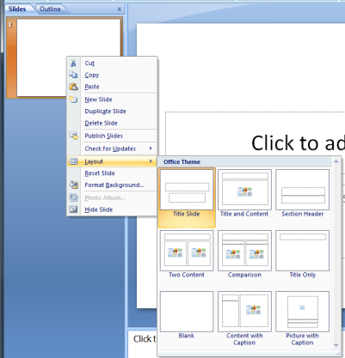
Demonstrate the various designs that can be applied to a slide by clicking on them in the Design tab. You can see even more of them by clicking the third little arrow under the up and down arrows (the down arrow with the line).
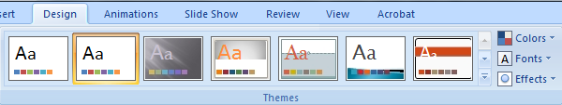

Adding Content to Slides
Choose a slide layout that contains a place to put text or other content (not just a title). Hover over the icons in the placeholder to see the tooltip associated with them. Click each one in turn to show what kinds of things you can add. Explain what you are seeing to the class.
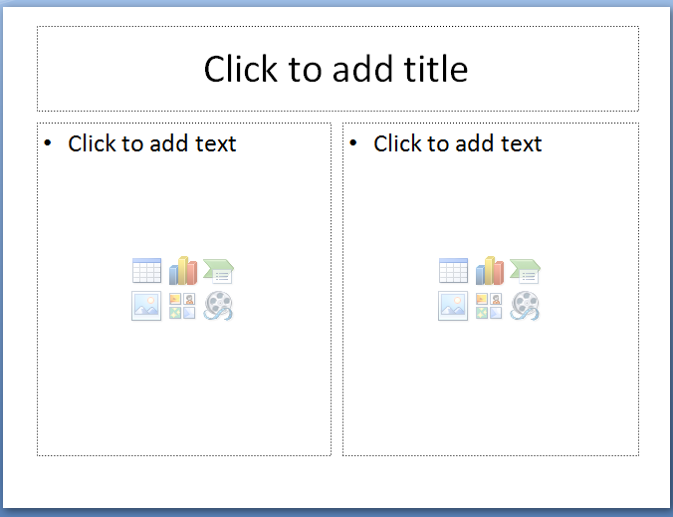
Pick one that makes sense to you and add that content.
Create a new slide with a content placeholder, and start adding text to it by clicking in it.
Create a bulleted list in the placeholder using the bullets icon in the Home tab.
Adjust the text formatting with the font style, size, and colour in the Home tab. This will be similar to show it is done in Word.
Type enough text in the content placeholder so that it will no longer fit. Point out how PowerPoint automatically shrinks the text to fit.
Select the entire content frame and use the increase/decrease font size buttons (the A’s with the up and down arrows) to change the size of the text.

Notes and Slide Management
Increase the size of the notes pane so the class can clearly see it. Type some notes in there.
To prove the notes can’t be read by the audience, play the show by clicking the From Current Slide button in the Slide Show tab.
Show how to print the notes. Click the Office Button and click Print. In the bottom left of the dialog, choose Notes Pages for Print What. Click Preview to show what will print.
Explain and show how to navigate through slides using the up and down arrow keys, the scroll bar at the right, and the thumbnails at the left.
Show how to move slides by dragging them around in the thumbnails area.
Show that you can select a slide in the thumbnails area and press delete to get rid of it. You can also right click a slide in the thumbnails area and choose delete from there.
Show that the icon in the bottom right, just before the zoom slider, will also start the slide show from the current slide.
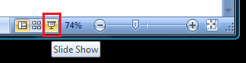
Finally, demonstrate the slide sorter either with the icon at the bottom or with the View tab.
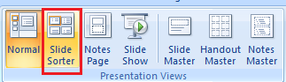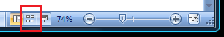

Drawing
Show how to insert various shapes from the Home or Insert tabs. On the home tab, some arrows and similar objects are shown, and in the Insert tabs you click on the Shapes button.
Show how to insert text into an object. Create an oval using the Shapes button, then click on the Text Box in the Shapes button. Click the oval and enter the text.
Demonstrate the various ways to change your shape object properties:
- Double click the object to bring up the Format tab at the top of the window.
- Right click an object and choose Format Shape.
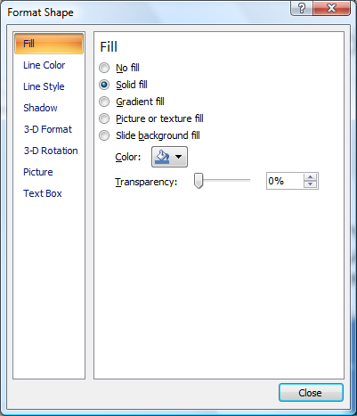
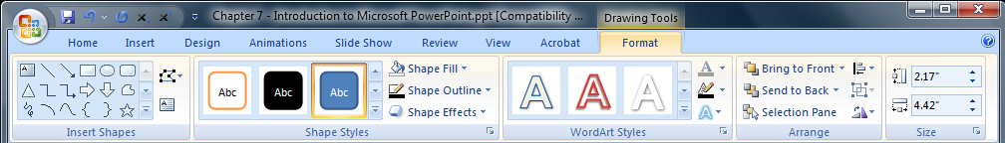
Play around with the various formatting options with a few of your objects.
Select a few objects and demonstrate what happens when you click various choices in the Arrange button in the Home tab.

Animations
Make sure you have a few different slides so you can demonstrate slide transitions.
Add a slide transition between two slides. Select the slides then apply the transition desired. Choose the transition from the Animations tab. Demonstrate a few different transitions by starting the slide show from the current slide, and moving between the two that have the transition.
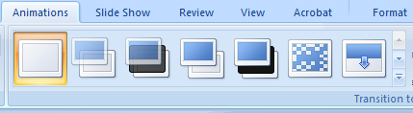
Show how to remove a slide transition by clicking on No Transition.
Next, demonstrate the custom animation option. Choose Custom Animation in the Animations tab.
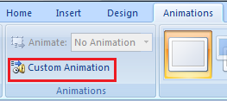
Select an object in the slide (such as a text box, image, or shape). Click the Add Effect button in the custom animation box on the right.
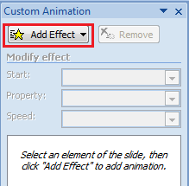
Look through the various effects and pick one. Play the presentation from the current slide to demonstrate. Show several other animations.
Experiment with the options for a particular animation by selecting it and clicking on the downward arrow. In particular, try to demonstrate what it means to start “on click” vs “with previous” vs “after previous.” Play with the other options as well.

Slide Master
Explain that a slide master allows you to make a design change to the layout of a slide that will affect all slides at once (for example, fonts, colours, positioning, footers, etc). This avoids repetition and makes the size of the file smaller.
Make sure you have several slides of different layouts in the presentation.
Show how to open the slide master by clicking on the View tab and choosing the Slide Master button. Point out that the root slide is probably not selected, then select it. The root slide is the first one in the list on the left. Changing the root slide affects things in ALL layouts.
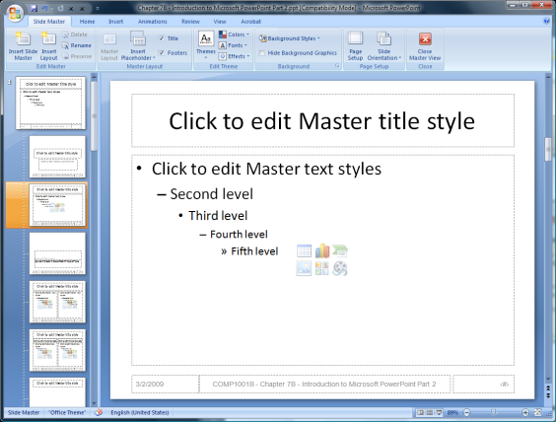
In the root slide, click the text box holding the title. In the Home tab, choose bold and a different colour for the text. This will update all layouts. Close the master view using the big red X in the Slide Master tab. Point out the change in the rest of the presentation.
Repeat the previous steps, but this time add an image to the background of the slide instead. You may need to save one off the Internet. You may also want to place the image behind all the current text, etc. Do this by selecting it, going to the Home tab, clicking Arrange, and then Send to Back. Close the Master view again and show the changes in the presentation.

